

**Capstone Project Report**

**Report 1 – Project Introduction**

– Hanoi, October 2022 –

**Table of Contents**

I. Record of Changes 3

II. Project Introduction 4

1. Overview 4

1.1 Project Information 4

1.2 Project Team 4

2. Product Background 4

3. Existing Systems 4

3.1 System name1 4

3.2 System name2 4

4. Business Opportunity 4

5. Software Product Vision 5

6. Project Scope & Limitations 5

6.1 Major Features 5

6.2 Limitations & Exclusions 6

# I. Record of Changes

|  |  |  |  |
| --- | --- | --- | --- |
| Date | A* M, D | In charge | Change Description |
| 07/10/2022 | A | ThongPQ | Overview; Product Background; Business Opportunity; Product Vision |
| 07/10/2022 | M | GiangNT | Overview; Product Background; Business Opportunity; Product Vision |
|  |  |  |  |
|  |  |  |  |
|  |  |  |  |
|  |  |  |  |
|  |  |  |  |
|  |  |  |  |
|  |  |  |  |
|  |  |  |  |
|  |  |  |  |
|  |  |  |  |
|  |  |  |  |

*A - Added M - Modified D - Deleted

# II. Project Introduction

## 1. Overview

### 1.1 Project Information

* Project name: FU House Finder
* Project code: FHF
* Group name: SWP490-G1
* Software type: Web App

### 1.2 Project Team

|  |  |  |  |
| --- | --- | --- | --- |
| **Full Name** | **Role** | **Email** | **Mobile** |
| Nguyen Tat Trung | Lecturer | Trungnt77@fe.edu.vn | 0904399139 |
| Nguyen The Giang | Leader | GiangNTHE153046@fpt.edu.vn | 0944961228 |
| Phung Quang Thong | Member | ThongPQHE150340 @fpt.edu.vn | 0987206969 |
| Bui Ngoc Huyen | Member | HuyenBNHE150346@fpt.edu.vn | 0346034217 |
| Nguyen Thu An | Member | AnNTHE150432@fpt.edu.vn | 0815709131 |
| Nguyen Tri Kien | Member | KienNTHE150160 @fpt.edu.vn | 0987999975 |

## 2. Product Background

Currently, the following major problems remain:

* The input data to the inn's website is currently not computerized to the smallest management unit, each room, to be included in the system. Therefore, the amount of high-quality data in existing web pages is not much.
* The current website searches for low-quality results for users because the status of the inn has not been updated to reflect reality. Due to the fact that the status of the room changes quite often and the host only puts general information on the Facebook group created by the admissions office, so it is difficult to find in large quantities to provide information for students to enroll with a large number of rooms to rent to students.

The student affairs department has a list of the names of the innkeepers who have been confirmed by the admissions office that the innkeeper exists in fact, the correct address and there may be a number of rooms in the area around FPT Hoa Lac University including 5 communes: Binh Yen, Thach Hoa, Tan Commune, Shareholders, Ha Bang save as excel file. The student affairs department also created 1 Facebook group for hostel owners to post and read about the rooms. With Facebook groups and a list of hostel owners, it still partially meets the rental information needs of a large number of old and new current students.

The problem situation is:

* The data of the motel rooms is not specific, the inn owner only posts general to the FB group as "Room for rent, xxx square meters, price, address, contact number ....". So, when enrolling new students, thousands of students want to find a hostel in 1 short time like when enrolling at the beginning of the year, the admissions office could not answer for thousands of students, parents' status of the large number of available rooms for rent around the campus area.
* The number of individual rooms for each student, the current way of doing it on the FB group meets but the large number of new students cannot rent a dormitory but having to outsource, the Facebook group method is not effective.

How to refresh:

* Digitize all accurate data to each room of all residents who have rooms for rent around Hoa Lac area. The smallest management unit is each room.

## 3. Existing Systems

### 3.1 System name1

*[Write the brief descriptions of the system, the link, the system actors, features, pros, cons, etc.]*

### 3.2 System name2

…

## 4. Business Opportunity

The system will be 1 tool for inn owners to regularly update the status of the motel room to reflect the reality or vacancy status in the future can also be searched. Therefore, the system helps innkeepers increase the annual rate of rental rooms and can collect money from the innkeeper on a monthly, or quarterly basis. If they find tool valuable, they are willing to pay.

## 5. Software Product Vision

The capstone team is expected to coordinate with the admissions department and the innkeeper to put the actual data of each room such as text description, photo of 3 each room on google sheet. Then the capstone group will run the excel file import function to put data into the data base in large quantities to serve the search. This works that want to finish into the 20/10/2022.

capstone group system intends to develop with the desire to put into practice with the most basic features by the end of 11/2022 in Hoa Lac. If it is ok, it is expected that the system can be deployed at 5 campuses Hoa Lac, Ho Chi Minh City, Can Tho, Da Nang, Quy Nhon.

## 6. Project Scope & Limitations

*[The project scope defines the concept and range of the proposed solution. It’s also important to define what will not be included in the product. Clarifying the scope and limitations helps to establish realistic expectations of the many stakeholders. It also provides a reference frame against which proposed features and requirements changes can be evaluated. Proposed requirements that are out of scope for the envisioned product must be rejected, unless they are so beneficial that the scope should be enlarged to accommodate them (with accompanying changes in budget, schedule, and/or resources)]*

### 6.1 Major Features

*[Include a numbered list of the major features of the new product, emphasizing those features that distinguish it from previous or competing products. Specific user requirements and functional requirements may be traced back to these features.]*

<<Sample:

FE-01: Order and pay for meals from the cafeteria menu to be picked up or delivered.

FE-02: Order and pay for meals from local restaurants to be delivered.

FE-03: Create, view, modify, and cancel meal subscriptions for standing or recurring meal orders, or for daily special meals.

FE-04: Create, view, modify, delete, and archive cafeteria menus.

FE-05: View ingredient lists and nutritional information for cafeteria menu items.

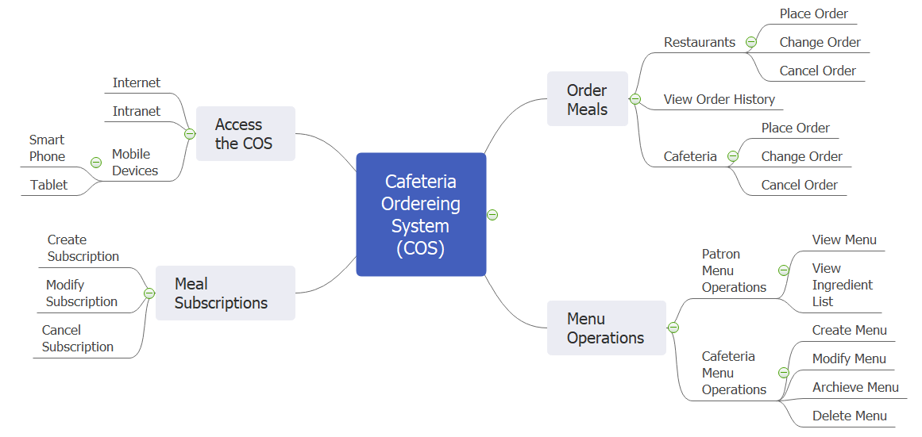

>>

### 6.2 Limitations & Exclusions

*[Identify any product features or characteristics that a stakeholder might anticipate, but which are not planned to be included in the new product.]*

<<Sample:

LI-1: Some food items that are available from the cafeteria will not be suitable for delivery, so the menus available to patrons of the COS must be a subset of the full cafeteria menus.

LI-2: The COS shall be used only for the cafeteria at the Process Impact campus in Clackamas, Oregon.

>>